|  |  |
| --- | --- |
| **Team ID** | PNT2022TMID51066 |
| **Project Name** | AI-powered Nutrition Analyzer forFitness Enthusiasts |

**Create HTML Pages**

• We use HTML to create the front-end part of the web page.

• Here, we have created 3 HTML pages- home.html,

image.html,imageprediction.html, and 0.html.

• home.html displays the home page.

• image.html is used for uploading the image

• imageprediction.html will showcase the output

• 0.html is to showcase the result. It tells the action to be performed on

imageprediction.html while showcasing the result. For more

information regarding HTML https://www.w3schools.com/html/

• We also use JavaScript-main.js and CSS-main.css to enhance our

functionality and view of HTML pages.

**HOME PAGE**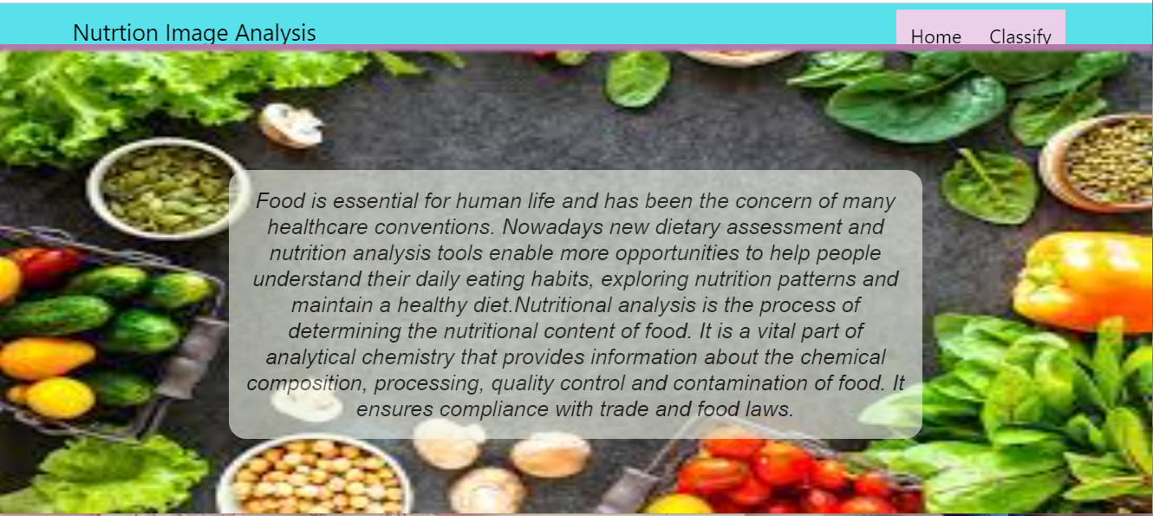

**IMAGE Page**

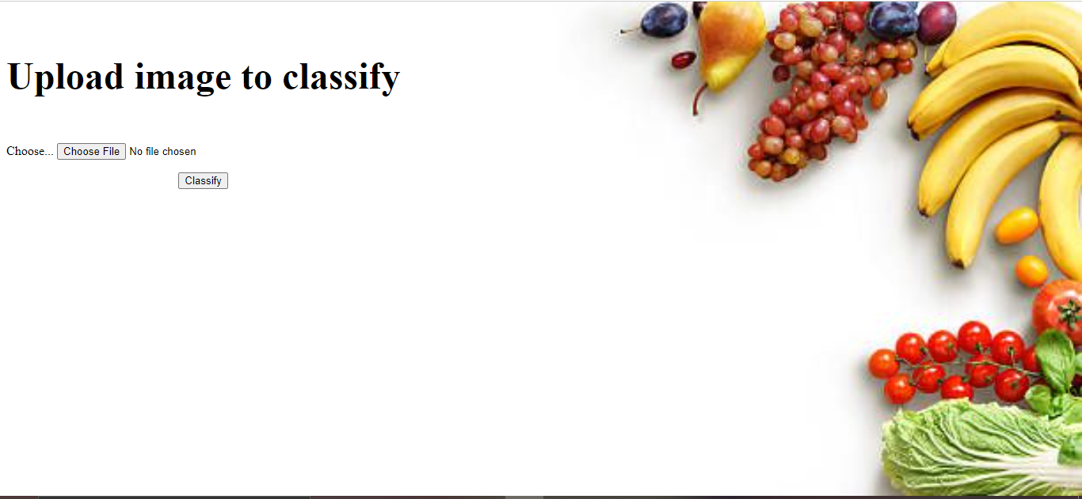

**IMAGE PREDICTION PAGE**

